**Frontend Development with React.js**

**1.INTRODUCTION:**

**PROJECT TITLE**: **FitFlex: Your Personal Fitness Companion (React Application)**.

**TEAM LEADER: NANCY .A**

**EMAIL ID: nancy27raj@gmail.com**

**TEAM MEMBER:** NANDHINI.B

**EMAIL ID:** nandhiniboopathi29@gmail.com

**TEAM MEMBER:** RUBINI.S

**EMAIL ID:** rubinisureshkumar3@gmail.com

**TEAM MEMBER:** VIJAYADHASHNI.E

**EMAIL ID:** ilakiyai851@gmail.com

**2.PROJECT OVERVIEW:**

**PURPOSE:** The overarching aim of FitFlex is to offer an accessible platform tailored for individuals passionate about fitness, exercise, and holistic well-being.

**FEATURES:** Exercises from Fitness API, Visual Exercise Exploration, Intuitive and User-Friendly Design, Advanced Search Feature.

**3.ARCHITECTURE:**

**COMPONENT STRUCTURE:**

**User-Friendly Experience:** Develop an intuitive interface that facilitates easy navigation, enabling users to effortlessly discover, save, and share their preferred workout routines.

**Comprehensive Exercise Management:** Provide robust features for organizing and managing exercise routines, incorporating advanced search options for a personalized fitness experience.

**Technology Stack:** Harness contemporary web development technologies, with a focus on React.js, to ensure an efficient and enjoyable user experience.

**STATE MANAGEMENT:**

FitFlex prioritizes a user-centric approach from the ground up. The engaging user interface (UI), likely built with a framework like React Native, keeps interaction smooth and intuitive. An API client specifically designed for FitFlex communicates with the backend, but with a

twist: it leverages Rapid API. This platform grants access to various external APIs, allowing FitFlex to potentially integrate features like fitness trackers, nutrition data, or workout tracking functionalities without building everything from scratch. This approach ensures a feature-rich experience while focusing development efforts on the core FitFlex functionalities.

**ROUTING:**

React Router provides a flexible and widely used solution for managing client-side routing in React applications, allowing developers to define routes and render different components based on the current URL.

**4.SETUP INSTRUCTIONS:**

**PREREQUISTIES:** Node.js and npm, React.js.

**INSTALLATION:**

1.INSTALL GIT

Git: Download and installation instructions can be found at: <https://git-scm.com/downloads>

2 .CHOOSE A REPOSITORY

3. OPEN THE TERMINAL OR COMMAND PROMPT

4. NAVIGATE TO THE DESIRED DIRECTORY

5. CLONE THE REPOSITORY

bash

git clone https://github.com/user/repository.git

Replace <https://github.com/user/repository.git> with the actual URL of the repository you want to clone.

6. WAIT FOR THE CLONE TO COMPLETE

7. VERIFY THE CLONE

8. NAVIGATE INTO THE CLONED REPOSITORY

Choose a code editor or Integrated Development Environment (IDE) that suits your preferences, such as Visual Studio Code, Sublime Text, or WebStorm.

* Visual Studio Code: Download from <https://code.visualstudio.com/download>
* Sublime Text: Download from <https://www.sublimetext.com/download>
* WebStorm: Download from <https://www.jetbrains.com/webstorm/download>

**5.FOLDER STRUCTURE:**

**CLIENT:** Folder structure contains the files and folders that are present in the directory. There are multiple files and folders, for example, components, assests, pages, styles.

**UTILITIES:** String Manipulation, Data Transformation, DOM Manipulation.

**6.RUNNING THE APPLICATION:**

* + Navigate into the cloned repository directory and install libraries:

cd fitness-app-react npm install

* + To start the development server, execute the following command:

npm start

Open your web browser and navigate to [http://localhost:3000](http://localhost:3000/).

**7.COMPONENT DOCUMENTATION:**

**KEY COMPONENTS:**

**Components:** It is one of the core building block of React. They have the same purpose as Javascript functions and return HTML.

**Assests:** Images, icons are stored in the assests folder. Organizing assests in a dedicated directory keeps your project clean and makes it easy to locate and manage these files.

**Styles:** This directory contains CSS or other styling files used to define the visual appearance of your application.

**Pages:** A standard directory where you store all the individual page components of your application.

**REUSABLE COMPONENTS:**

**BUTTONS:** A reusable button component can be used throughtout the application, with different labels, colors, and behaviors.

**NAVIGATION:** A reusable navigation component can be used to create different navigation menus, with varying items and behaviors.

**8.STATE MANAGEMENT:**

**GLOBAL STATE:** Requires a dedicated state management solution like React Context API or external libraries like Redux.

**LOCAL STATE:** Managed using the useState hook in functional components.

**9.USER INTERFACE:**

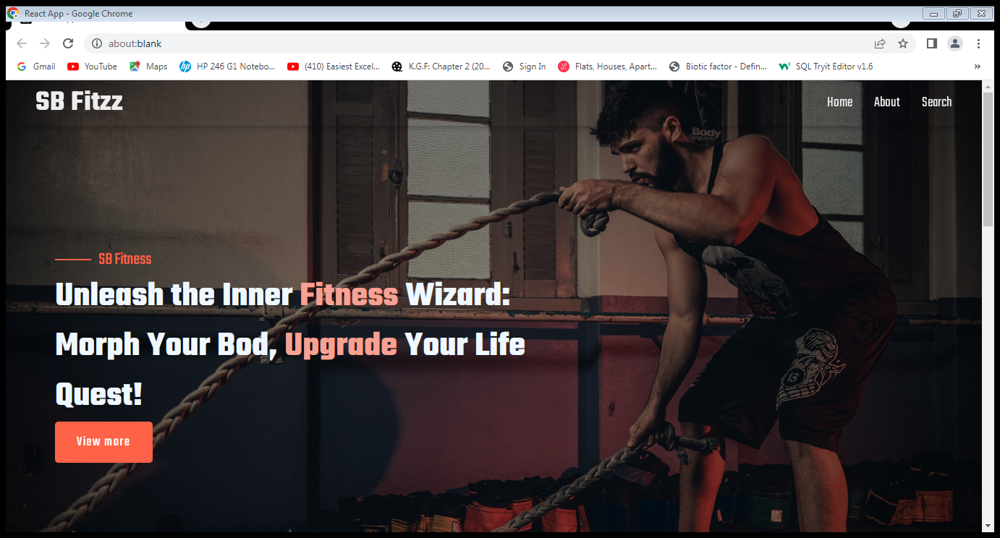

**10.STYLING:**

* Bootstrap/tailwind css
* Adding Animation
* Component-Specific Styling

**11.TESTING:**

Unit Testing is a way to verify that each part of a React application works as intended.

End to End Testing is a way to verify that entire work-flow from start to finish.

Code coverage: Tools like Jest as a testing framework, paired with Istanbul for code coverage reporting.

**12.SCREENSHOTS OR DEMO:**

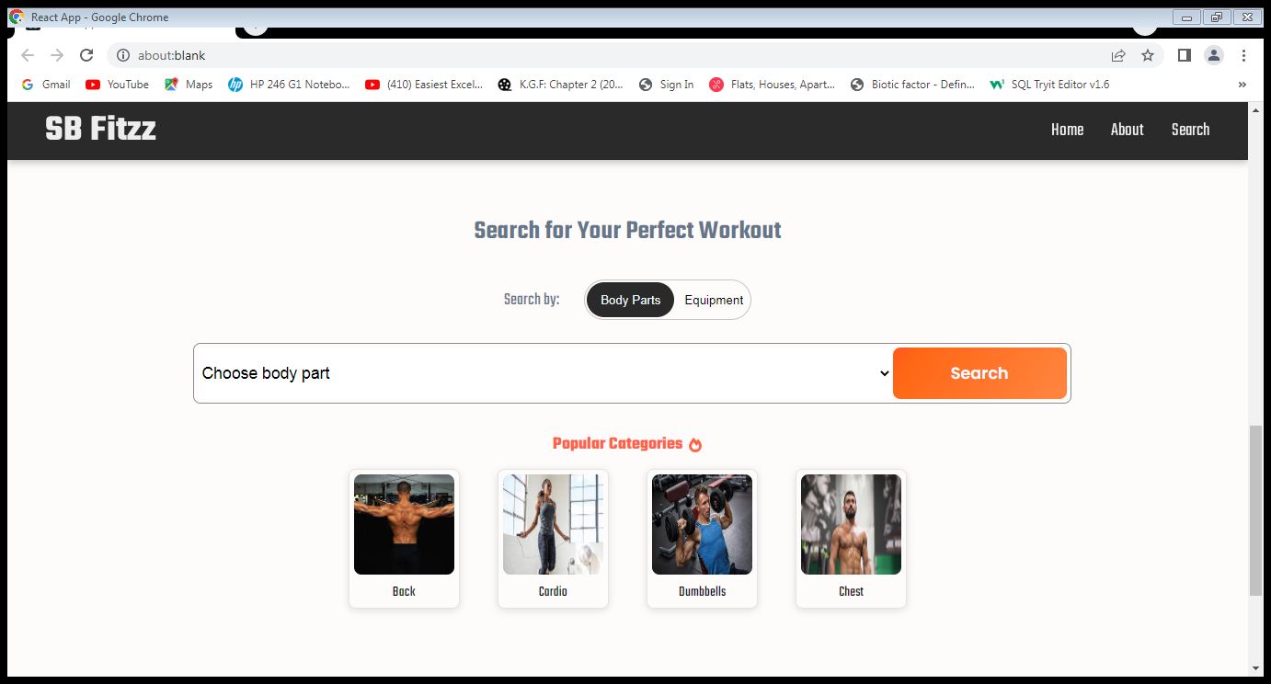

**13.KNOWN ISSUES:**

We aware of the bugs or issues that users or developers should be aware of.

**14.FUTURE ENHANCEMENTS IN FITNESS APP DEVELOPMENT:**

**VOICE ASSISTANT INTEGRATION:**

Fitness App will integrate with voice assistants, such as Alexa and Google Assistant, to provide users with a more seamless and hands-free experience.

**GAMIFICATION:**

Introduce challenges and score to encourage user engagement and motivation.

**\*\*\*\*\*\*\*\*\***